**What is data replication?**

Data replication is the process in which the data is copied at multiple locations (Different computers or servers) to improve the availability of data.

**Goals of data replication**

**Data replication is done with an aim to:**

* Increase the availability of data.
* Speed up the query evaluation.

**Types of data replication**

**There are two types of data replication:**  
  
**1. Synchronous Replication:**  
In synchronous replication, the replica will be modified immediately after some changes are made in the relation table. So there is no difference between original data and replica.  
  
**2. Asynchronous replication:**  
In asynchronous replication, the replica will be modified after commit is fired on to the database.

**Replication Schemes**

**The three replication schemes are as follows:**

**1. Full Replication**

In full replication scheme, the database is available to almost every location or user in communication network.  
  
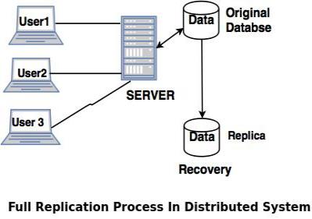  
  
**Advantages of full replication**

* High availability of data, as database is available to almost every location.
* Faster execution of queries.

**Disadvantages of full replication**

* Concurrency control is difficult to achieve in full replication.
* Update operation is slower.

**2. No Replication**

No replication means, each fragment is stored exactly at one location.  
  
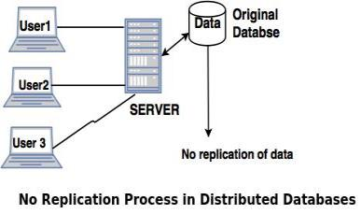  
  
**Advantages of no replication**

* Concurrency can be minimized.
* Easy recovery of data.

**Disadvantages of no replication**

* Poor availability of data.
* Slows down the query execution process, as multiple clients are accessing the same server.

**3. Partial replication**

Partial replication means only some fragments are replicated from the database.  
  
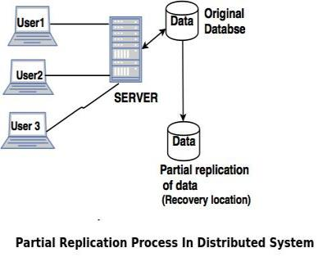  
  
**Advantages of partial replication**  
The number of replicas created for fragments depend upon the importance of data in that fragment.